Level 8 -> Level 9

The goal of this level is to find the pass to log into <http://natas9.natas.labs.overthewire.org>.

Username: natas9

After logging into level 8 we got a hint to get the password of next level. **There is a link to view the source code.** So, simply click on the link to view page source.

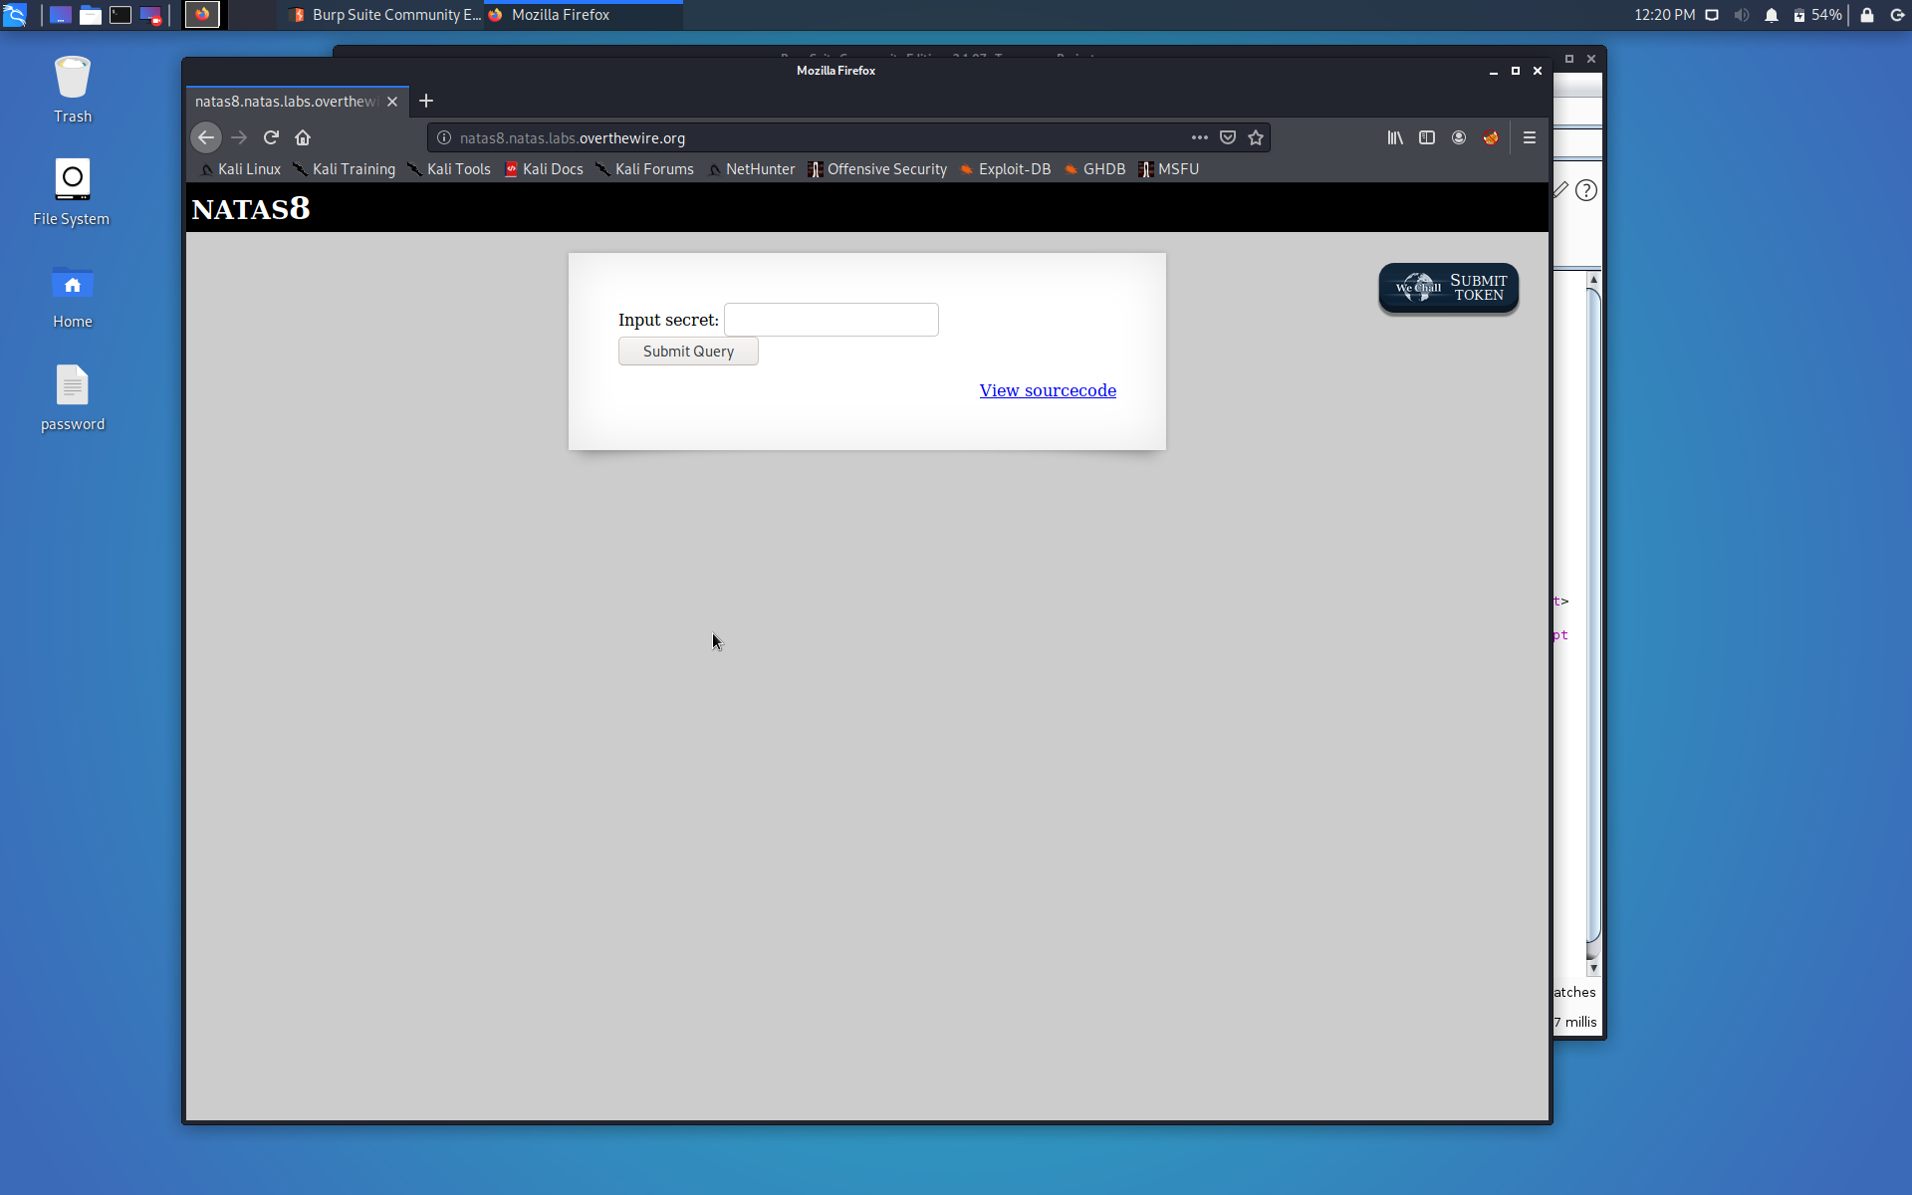

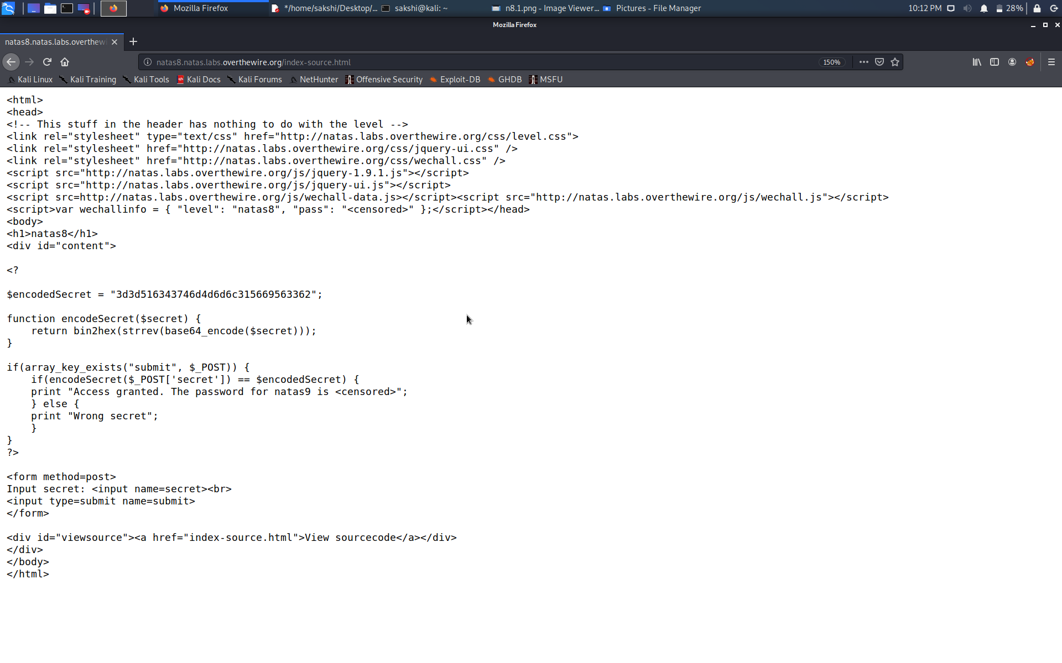

There is a function which is taking key entered by us, doing some changes(encoding) in the key and matches the result with the provided encodedSecret in the source code. We need to find the key that we have to enter so that we can get the next password.

We can decode the secret by reversing what the function is doing to the secret. Use the kali terminal to decode the secret.

And, here is the secret…

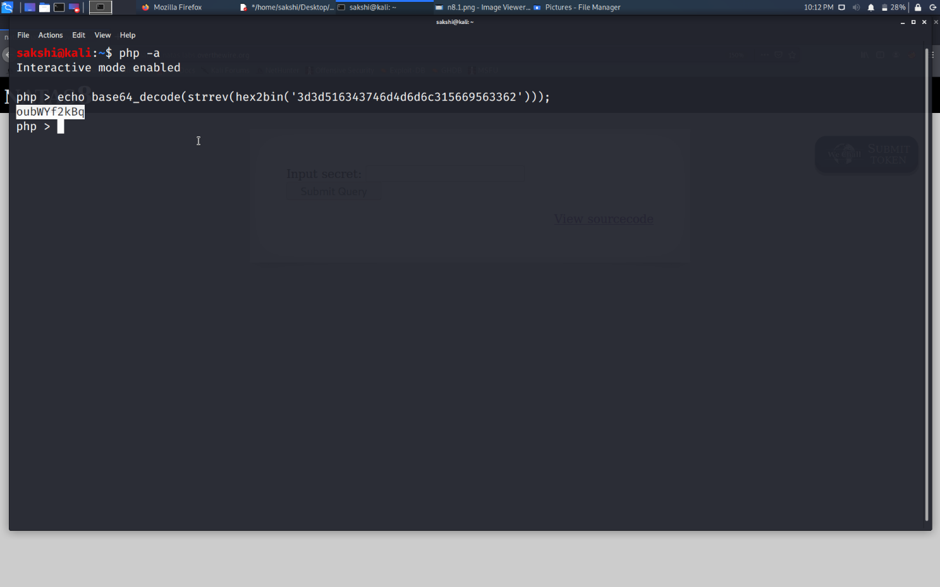

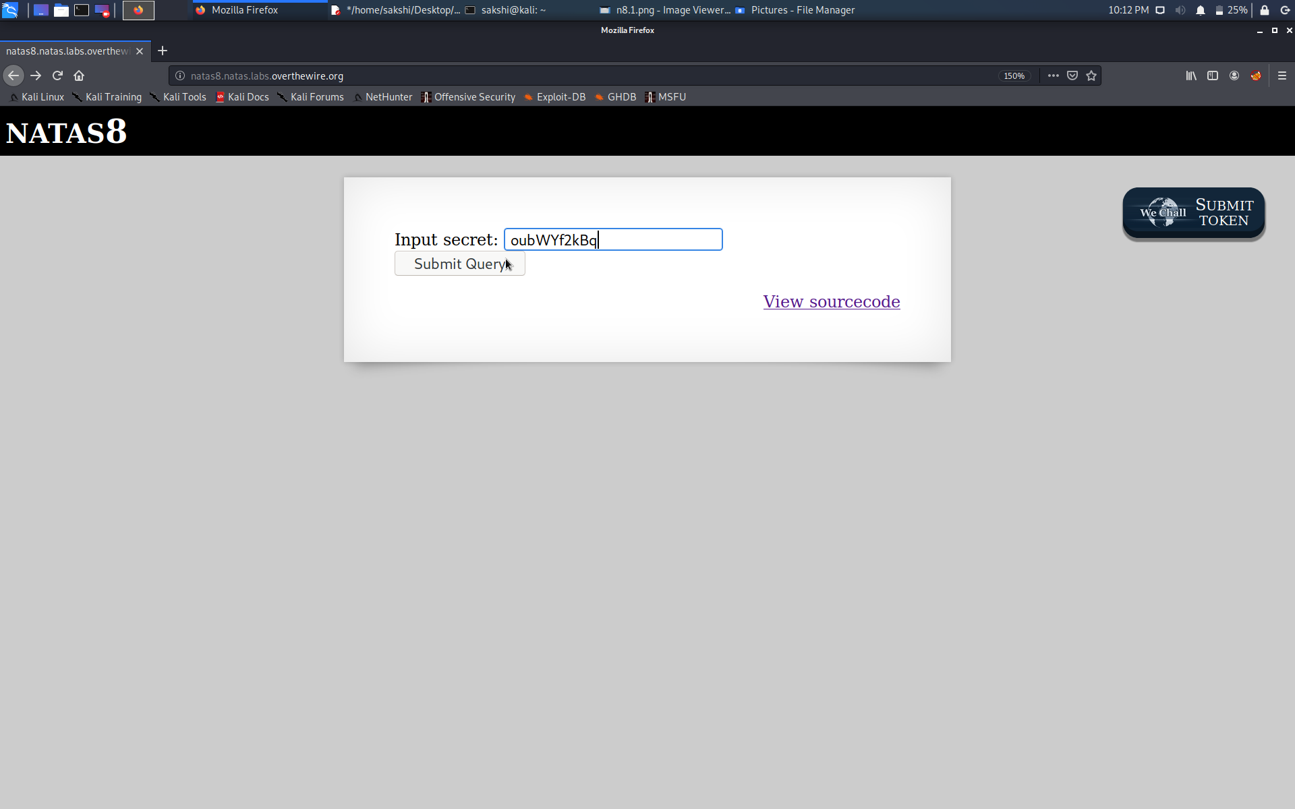

After entering the secret, we got the password to level 9.

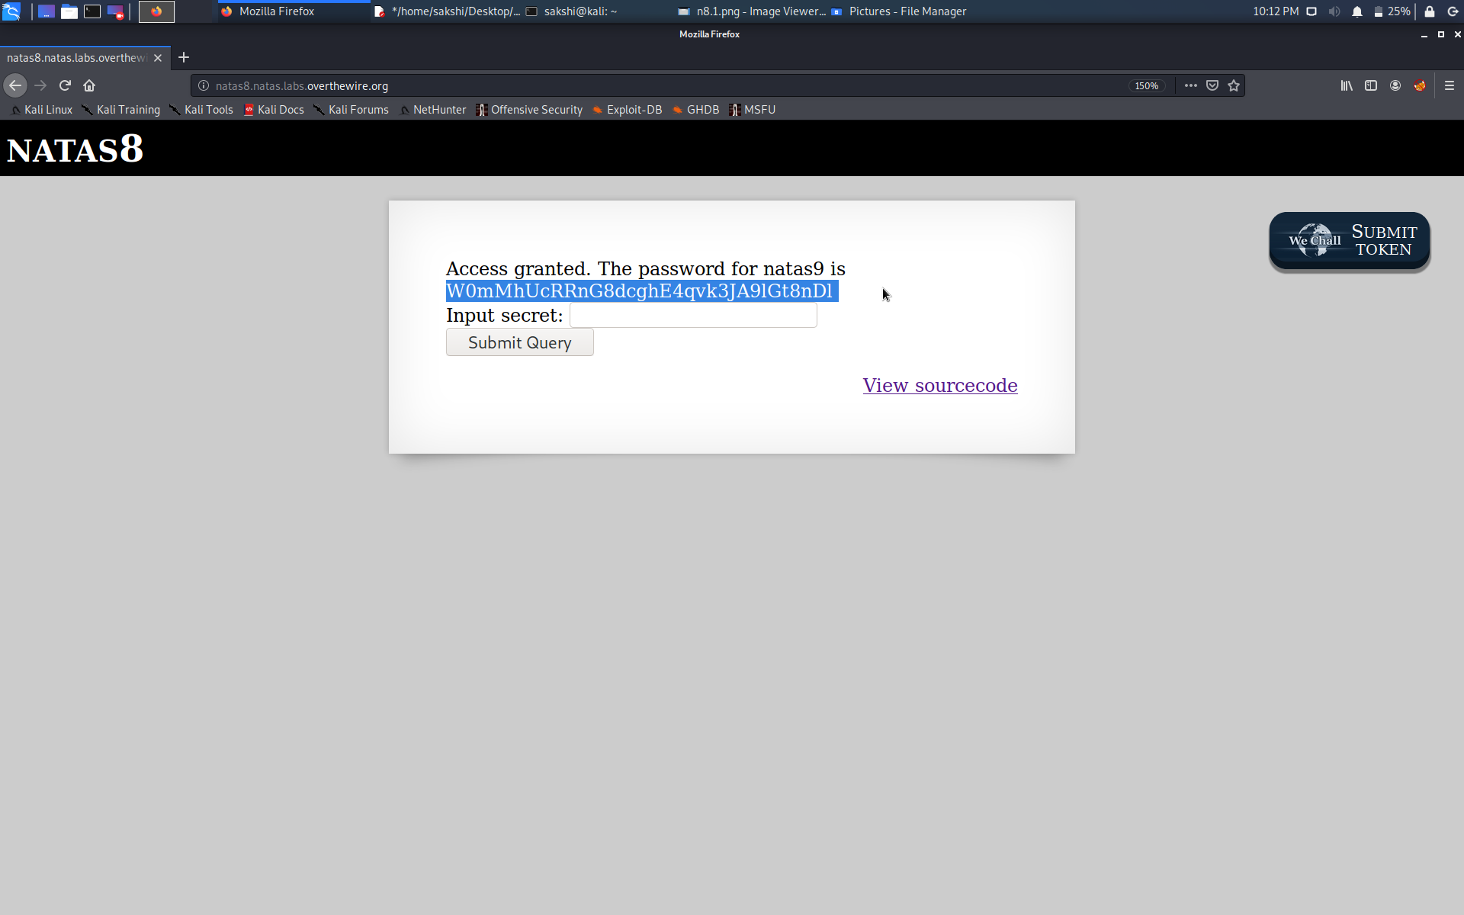

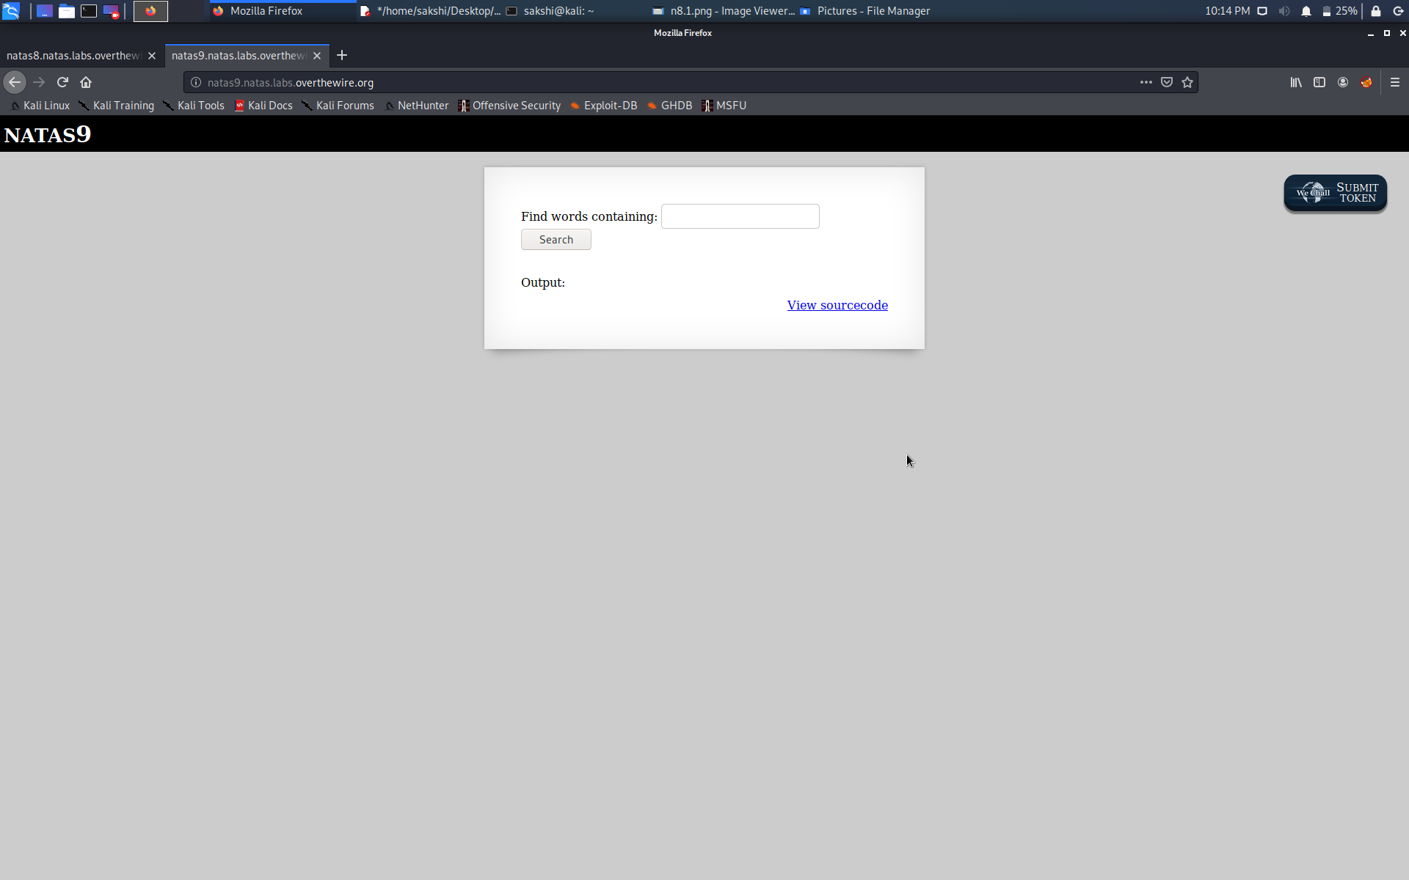

Successfully passed level 9.… 